SmartCon: A General Mechanism Generation Engine for Physical AI
David Tang
June 30, 2026

In previous articles, I introduced how SmartCon, driven by AI Agents, automatically generates massive amounts of robot ontology data.

But the true significance of SmartCon lies not only in robot design.

It proves something more important: any mechanical mechanism that can be described by parameters can become a data object for AI to automatically generate, optimize, and train.

This means that SmartCon is evolving from robot design software into a Physical AI Data Generation Engine.

Example 1: Redefining the Legs of Humanoid Robots

For example, our company has a patented robot leg structure.

Traditional humanoid robots typically require three joints per leg, thus requiring:

• Three motors

• Three reducers

• A multi-level control system

Our scissor-leg structure, however, achieves similar mobility using only:

• One motor

• One reducer

• One non-linear scissor mechanism

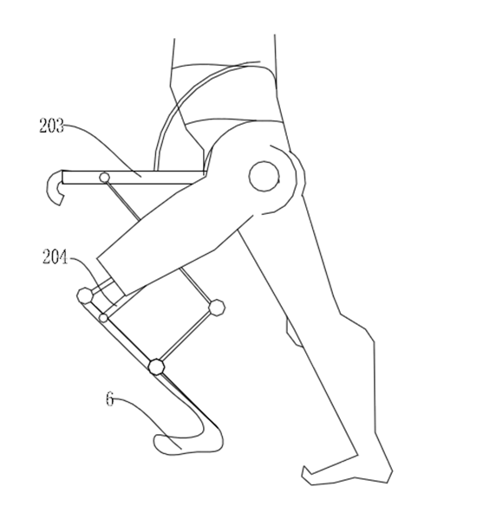
The truly important thing is not this structure itself.

Instead, SmartCon can automatically generate tens of thousands of different parameter combinations around this mechanism, calculating for each leg structure:

• Foot trajectory
• Energy consumption
• Stability
• Torque distribution
• Material utilization
• Control complexity

Ultimately, it automatically finds the optimal solution.

This means that the legs of humanoid robots no longer rely on engineers designing them one by one, but are automatically searched by AI throughout the design space.

Second example: Theo Jansen Mechanism
Dutch inventor Theo Jansen created the famous Strandbeest.

The entire machine consists of multiple eight-bar linkages, yet only requires a single motor to drive complex gaits.
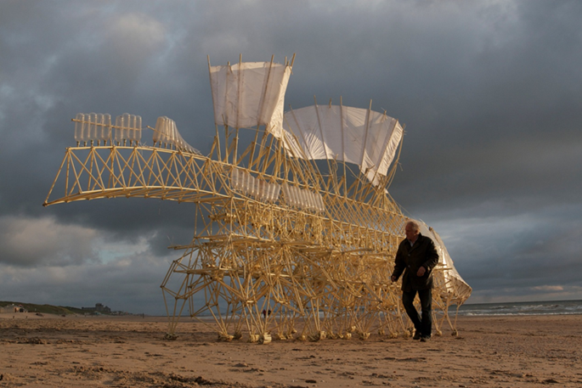
Traditional design methods rely on manual trial and error with different dimensions.
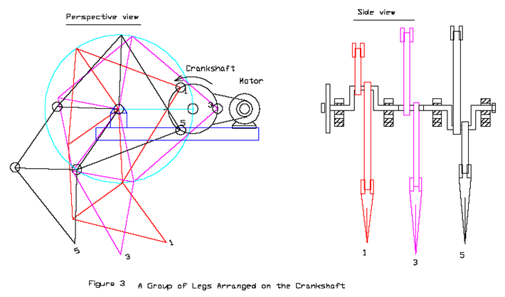

SmartCon can directly parameterize all bar lengths, angles, and installation positions.

It then automatically generates:

• Tens of thousands of gaits

• Tens of thousands of foot trajectories

• Tens of thousands of mechanism combinations

Finally, it automatically selects the optimal solution based on targets such as speed, stability, and energy consumption.

Engineers no longer search for answers,

but instead choose answers from the vast design space provided by AI.
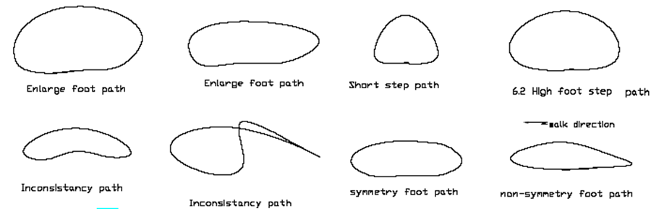

Third Example: Four-Bar Linkages in University Mechanical Engineering Courses

Even four-bar linkages in university textbooks on mechanical principles can be completely handled by SmartCon.
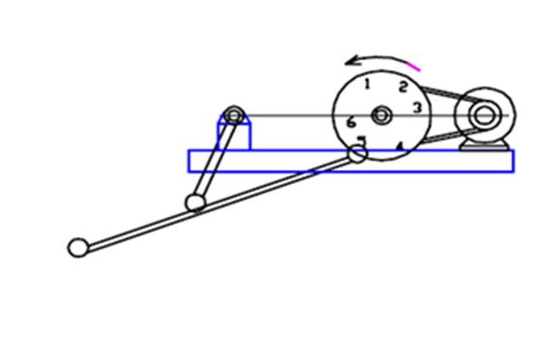
Traditional mechanical design often only has a few classic solutions.

In reality, a four-bar linkage has only four or five parameters, yet it can create an extremely vast design space.

SmartCon can automatically generate:

• Tens of thousands of mechanism motions

• Tens of thousands of end-effector trajectories

• Tens of thousands of velocity curves

• Tens of thousands of mechanical properties

Then it automatically optimizes based on specific industrial goals.

Crushers, packaging machines, stamping presses, mixers, automated assembly equipment…

All mechanisms can be redesigned using the same method.

The True Value of SmartCon

It's important to emphasize this point.

SmartCon automatically generates more than just a geometric image.

It outputs a complete data object.

Each mechanism contains:

• Parameters

• Topological relationships

• Editable CAD data

• Kinematic data

• Dynamic data

• Mechanical analysis

• Simulation results

• Trainable labels

Therefore, it is naturally data that AI can directly learn from.

This is completely different from traditional CAD.

CAD saves drawings.

SmartCon saves a computable, optimizable, and trainable physical world.

From Language Models to Physical Models

Today's large language models are trained on internet text.

Visual models are trained on images and videos.

So what will the next generation of Physical AI train?

The answer may be:
Training the robot itself.

Training industrial automated mechanisms.

Training motion trajectories.

Training mechanical topologies.

Training the entire physical world.

SmartCon is automatically generating this data.

It generates not just a robot, but an infinitely expandable robot design space.

In the future, car chassis, drone mechanisms, medical equipment, industrial automation, construction machinery, and even any parametric mechanical system can all enter the same AI data generation framework.

Physical Architecture of AI
For the past decade or so, AI has been learning from the digital world.

In the next decade or so, AI will begin learning from the physical world.

And the biggest bottleneck in the physical world is not computing power.

nor models.

but the lack of trainable physical data.

The significance of SmartCon lies precisely in automatically generating this data.

It connects CAD, CAE, robot design, mechanism optimization, digital twins, and AI agents.

It is not the next generation of CAD.

It is more like:

The Data Generation Layer in the Physical Architecture of AI.

When AI can automatically generate, evaluate, optimize, and train billions of mechanisms, robot design will truly enter the era of AI autonomous evolution for the first time.

